John Robinson

Final Project Writeup

1. Problem Statement

The most important conceptual idea of this new simulation is to see if the quarantine is having any major effect on the corona virus based of our previous data mixed with newer and more relevant data as some time has passed since then. The problem broken does comes down to the effect that the quarantine has on the infection rate and the other variables.

Put simply the effects the quarantine has had on slowing down the COVID-19

1. Assumptions

Assumptions to make are that the quarantine has either been successful or not or something in between. There are many variables to take into account for this scenario, as I write this after the work is done, the sheer number of variables if overwhelming large. But the main ones are the there is are two parts to my analysis and each have their own assumptions. For the first one birth rate is not included and will not be calculated. There is a set death/recovery rate. Both were determined based on averages from numerous sources due to variance. The infection rate due to lack of public information on an exact number was determined by averaging the percentage of people who got infected over the last 7 day period as it is the most recent infection rate. There quarantine exact numbers are also vague but I found an exact report of a bit over 90 percent are quarantined so I am making the assumption that within ten days of the quarantine start 90 percent of the population are quarantined. Around 10 percent a day increase. The lock down start date is the average of most states at about march 19. A little bit early. The information before may 5 is all taken from the sources directly while the information after is predictive based on the formulae. There will be a different quarantine infection rate for those quarantined and those who are not. For the second set of spreadsheet which more analyzes the quarantines effectiveness mathematically the assumptions are that there is a reproductive rate for the virus while unquarantined and one for when a lockdown is in effect. There conditions of the 2 weeks for either death or recovery are the same. The information is not as exact due to the nature of the reproductive theory. The idea of the reproductive theory is that it is the amount of people an infected person will in turn infect. Based on recent statistics that number is 2.5 in the US and 1.5 for quarantined citizens. Lastly, we assume all tests are for the US in general not the world. All rates are averages across the United States. Death due to anything other than COVID related death is not included. For the sake of simplicity, the recovered will not be able to become sick again only in the second data set. The first one has this.

1. Defining Variables

Primary variables will be very similar to previous in class assignment but will some adjustments. They will be population, recovered, infected, dead, quarantined and unquarantined. There will be infection rates for quarantined and nonquarantined. Death rates, and recovery rates will be included. Specifically for the second data set there will be reproductive rate for lockdown and non-lockdown citizens which is the rate at which infected citizens infect others. So, for example a reproductive rate is 2.5 On average a person will infect 2.5 other people before recovery or death. I had several of similar rates, especially the death rate, there is a lot of varying information that comes in conflict in each other so sometimes I either used personal generated data or specifically noted rates.

* My formulae for the first data set were

**Delta I = ( QuarPop*QuarInfectionRate)+(NonQuarPop*NonQuarInfectionrate)-Delta D-Delta R**

Both Delta D and Delta R from 4 weeks prior due to infection incubation time then actual time until death or recovery

**Delta R = Delta I * recoveryRate**

**Delta D = Delta I * deathRate**

Both instances of Delta I were from 4 weeks prior same as above comment

**R = Rn-1 + Delta R**

**D = Dn-1 + Delta D**

**I = In-1 + Delta I**

**H = Hn-1 – I + R**

* Second Data Set

All the same as above except

**I NoQuar = I n-1 * R0**

**I Quar = I n-1 * R**

R0 being reproductive rate for virus with no quarantine and R being with quarantine

1. Getting a solution

Despite the lack of reliable information out there, I think I can say with relative safety that I can answer my initial question. With the information I have gathered it is clear that COVID-19 is being significantly affected by the lockdown. I shudder to think if it was not enacted sooner. Through a combination of WHO and CDC reports, predictive graphing and reverse engineering infection rates I have come up with some models that more a show me the significant effect the quarentine is having.

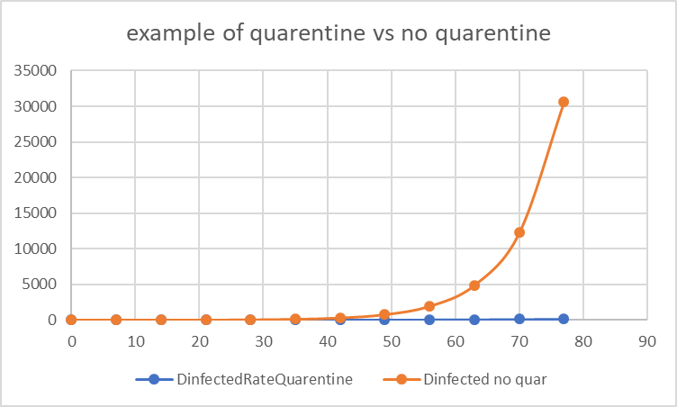

Coming down to the basic comparison is the second data revolving around the reproductive rates of the virus in its current form. When it comes down to it the exact growth rates haven’t been determined but the doubling factor of a quarantined infected citizen and not are very different. In several Pubmed.gov articles I found reproductive rates with fairly low ranges of about 2.5 for non-quarantined and 1.5 for quarantined. Some examples went as high as 4. The rate was around 8 during the initial Wuhan outbreak. To reiterate what this means it’s the expected number of other people a person will probably infected during the a set duration of seven days. The larger number of infected the more it will increase. This formula is quite drastic as with completely no quarantine the population gets sick instantly.

But then with the reproductive rate changed down to 1.5 every 7 days as according to that medical journal the results are changed to the extreme. Nearly no population is lost.

Despite being less useful I thought it would be relevant to have a graph of the current state of COVID-19 the yellow dot on the middle left side was the beginning of the lockdown in the US. When I started the project, I thought due to the lack of information see the curve would influence my decision of the effectiveness of the virus. From a glance of what is supposed to be an exponential curve it does appear to have slowed but not stagnated. The right third half is mostly predictive data but everything from about the middle to the beginning is issued directly from the WHO. Where the virus goes from here is going to be up to the governments of the world and if they can’t keep up this quarantine until a vaccine is produced cause as with some of the above charts the large the data size the quicker it will spread.

I had less success with my first data set despite being more complex. I think it relied on having correct rates and many of my rates were somewhat incorrect, Many of the recovery/death rates didn’t line up with the WHO/CDC reports when the numbers were compiled and there isn’t a set infection rate out so I averaged the percentages of the most recent results for the quarantined infection rate. My rate for infection for non-quarantined citizens was 1.6667 times the determined quarantine rate as that was how much larger the reproductive rate was for quarantine vs non quarantine. Just kind of build of it on an assumption.

Based of those rates there not much difference, It even appears as less in the first half but that is because I removed the quarantined part of the WHO issued data for consistency. This graph shows the quarantine has had less of an effect but it is more representative of real data and I think therefore still has sway on the final decision.

Sources

<https://www.ncbi.nlm.nih.gov/pubmed/32097725>

<https://virus-covid19.ru/>

<https://en.wikipedia.org/wiki/Coronavirus_disease_2019>

<https://coronavirus.jhu.edu/map.html>

<https://virusncov.com/>

<https://www.who.int/emergencies/diseases/novel-coronavirus-2019/situation-reports>

<https://art-bd.shinyapps.io/nCov_control/>

<https://www.nytimes.com/2020/04/23/world/europe/coronavirus-R0-explainer.html>

<https://www.ncbi.nlm.nih.gov/pmc/articles/PMC6002118/>

<https://www.statista.com/statistics/1109721/new-york-state-covid-cumulative-cases-us/>

<https://www.worldometers.info/coronavirus/coronavirus-cases/#recovered>

<https://www.cdc.gov/coronavirus/2019-ncov/cases-updates/cases-in-us.html>

<https://www.webmd.com/lung/covid-recovery-overview#1>

<https://www.aljazeera.com/news/2020/03/emergencies-closures-states-handling-coronavirus-200317213356419.html>